A-Z Household Services Application
MAD 1 Project Report, Sept 2024

Author
Ikram Abdulrehman Khan
23F2002017
23f2002017@ds.study.iitm.ac.in

My Experience with the Project
I am doing this online degree for programming and data science as a standalone degree. This term, I am actually doing both the theory and the project together so at first, the project from its statement seemed quite daunting to me to be honest, but as I delved deeper in both theory and project, each step became more manageable and enjoyable. So, what started as a tough challenge turned into a rewarding journey, making the entire experience not only easier but also incredibly fun and fulfilling. Of course, there were instances where I got stuck but they were also the ones that gave the most joy after I overcame them.

Description of the Project
In this project, we were supposed to create multi-user application (requiring one admin and other service professionals/customers) which will acts as a platform for providing comprehensive home servicing and solutions.
The frameworks allowed to be used were:
- Flask: for application code which also included Jinja2 for templating in HTML for dynamic webpage creation. Flask also included libraries like request, redirect, current_app, etc.
- Bootstrap: for HTML generation and styling (although not used by me as its optional).
- SQLite Database: as database for data storage.
- Flask-SQLAlchemy: to query and access the SQLite database.
- OS: to locate the database file.
- Datetime: to timestamping purposes.
- Matplotlib: to dynamically generate charts at run-time and save them in static folder.

Features of my application
Admin: An admin can monitor all the customers and professionals currently registered to the application and see all the details about them. The admin can also block or unblock a customer or a professional based on his reviews and ratings. Admin also has the sole authority to create a new service or update or delete an existing service currently provided on the application. He/she can also view all the service requests that have been made on the application.
An admin can also search for professionals, customers and services currently available on the application. He/she can also view a summary of ratings and requests on the dashboard.
Note: Blocking/Deleing a customer or professional is subjected to whether they have any requests open or tasks to be completed respectively. Similarly, a service cannot be deleted if there is any request for that service which is not yet closed.

Professional: A professional has to register on the application and has to be approved by the admin before he/she can start accepting the service requests. A professional has to register with a type of service that he/she can provide and within each service type, there are subtypes which make up the actual service request. For example, A professional of type Cleaning can cater to all services which are of type cleaning like full house cleaning, toilet & bathroom cleaning, etc.
On the professional’s dashboard, only services of his/her type and those which come from pincodes equal to or 1 more or less than his/her pincode will be displayed. The professional can either accept, reject or simply ignore that service request. However, once a service request is accepted by a professional, he/she can’t see or accept more requests until he/she finishes with the accepted request. A professional can also search from the services that he/she has done in the past.
Customer: A customer simply registers to the application and can begin to book services (no need of approval from admin). On the Customer’s dashboard, only those services are displayed which are available to his/her pincode. The Customer can also search for the services available at his/her location.
After the professional has completed the requested service, the customer has to close it and rate the professional who provided that service. The customer can also see a summary of his booking history and his average rating by all the professionals who provided him with any service.

DB Schema Design
Here, we have 5 tables in the database,
- Professionals: to store details of all the professionals registered to the application.
- Users: to store the details of all the customers registered to the application.
- Services: to store the details of all the services provided on the application.
- Service_Requests: to track all the service requests made on the application.
- Service_Professional_Response: to track the response of professionals to their respective requests.
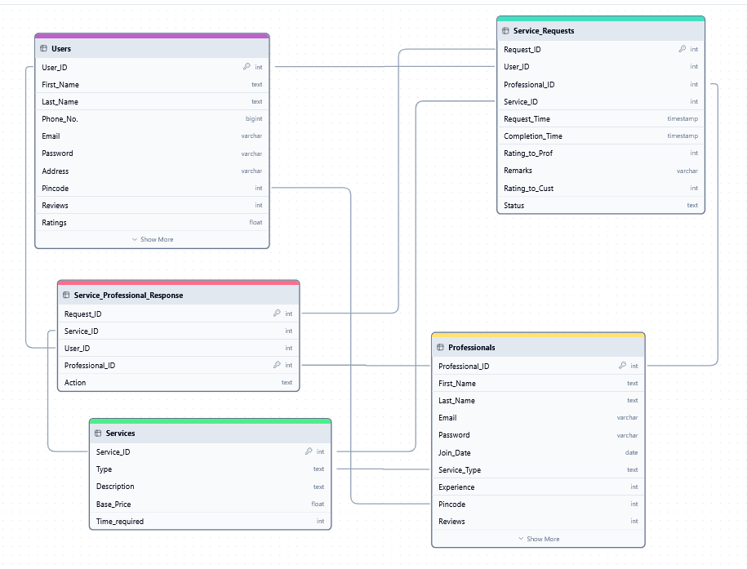

App Structure Summary
The main file is main.py and then there is an application folder which contains controllers.py, models.py, config.py and database.py. The templates folder contains all the HTML files required for the application. The static folder contains all the images made by matplotlib library. Then there is db_directory folder which contains the database file. At last, we have requirements.txt which contains all the necessary external libraries that needs to be installed for the use of application.

Wireframe: https://drive.google.com/file/d/1tnE4mHJVDGyiV-ehsygmIJcRxHTdUjbF/view

Video Link:

